Assignment 7:

# Class Diagram:

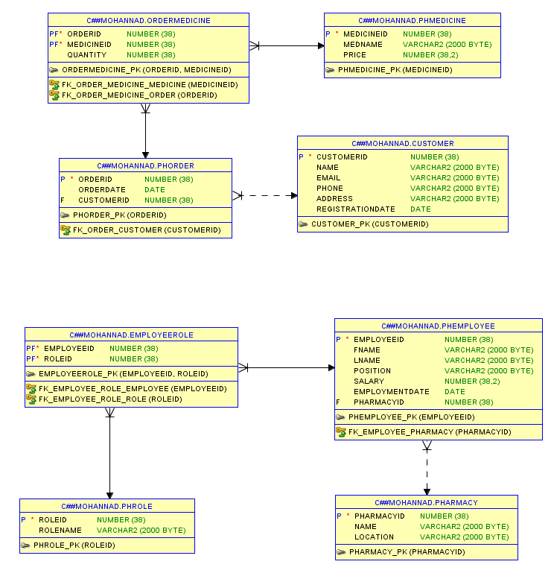

1. Retrieve all the data from all tables.

select * from Customer;

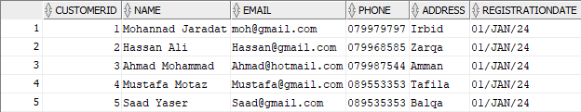

select * from PHEmployee;

select * from PHRole;

select * from EmployeeRole;

select * from Pharmacy;

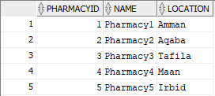

select * from PHMedicine;

select * from PHOrder;

select * from OrderMedicine;

2. Retrieve customers whose name contains an ‘a’ letter.

select * from Customer where Name like '%a%';

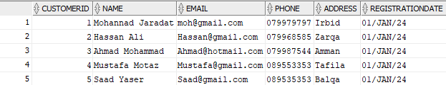

3. Retrieve employees whose position is Admin or Pharmacist. (Using two ways).

select * from PHEmployee where Position in ('Admin', 'Pharmacist');

select * from PHEmployee where Position = 'Admin' or Position = 'Pharmacist';

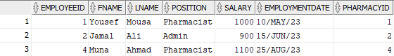

4. Retrieve the employees whose name ends with ‘d’ and contains five alphabets.

select * from PHEmployee where FName like '____d';

5. Retrieve employees who have the 3 highest salaries.

select * from PHEmployee

order by Salary desc

fetch first 3 rows only;

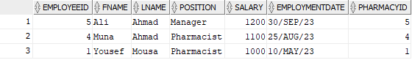

6. Retrieve the top 3 records from employee table.

select * from PHEmployee

fetch first 3 rows only;

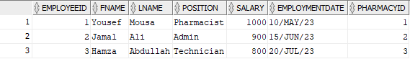

7. Retrieve the top 30% records from employee table.

select * from PHEmployee

order by Salary desc

fetch first 30 percent rows only;

8. Retrieve the name with the uppercase first letter (using built-in function).

select INITCAP(Name) as Capitalized_Name from Customer;

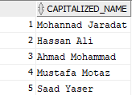

9. Set the salary value 600 JD when dating of employment before 27/10/2021.

update PHEmployee

set Salary = 600

where EmploymentDate < TO_DATE('2021-10-27', 'YYYY-MM-DD');

🡺 0 rows were updated.

10. Retrieve the name of customers who order medicine with the medicine name sort by

the medicine name.

select c.Name as Customer_Name, m.MedName as Medicine_Name

from PHOrder o

join Customer c on o.CustomerID = c.CustomerID

join OrderMedicine om on o.OrderID = om.OrderID

join PHMedicine m on om.MedicineID = m.MedicineID

order by m.MedName;

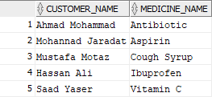

11. Retrieve the location of the pharmacies and the location for the employees using one query.

SELECT 'Pharmacy' AS Entity, Name AS EntityName, Location

FROM Pharmacy

UNION

SELECT 'Employee' AS Entity, FName || ' ' || LName AS EntityName, Pharmacy.Location

FROM PHEmployee

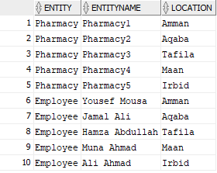JOIN Pharmacy ON PHEmployee.PharmacyID = Pharmacy.PharmacyID;

12. Retrieve the information of employees who live in the same location as the pharmacy.

SELECT e.EmployeeID, e.FName, e.LName, e.Position, e.Salary, e.EmploymentDate, p.Name AS PharmacyName, p.Location AS PharmacyLocation

FROM PHEmployee e

JOIN Pharmacy p ON e.PharmacyID = p.PharmacyID

WHERE p.Location = (SELECT Location FROM Pharmacy WHERE PharmacyID = e.PharmacyID);

